04/21/2022 第十週 線上教室

本週介紹國會預算程序

講義Ch. 14 p413 授權與撥款

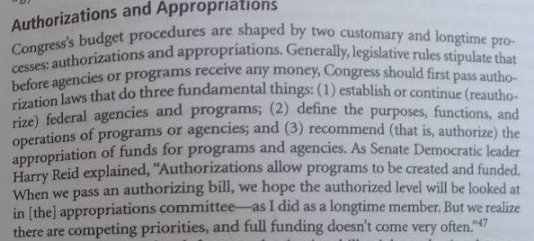

授權法為政策規範，據以建立聯邦的機關與業務計畫，但實際提供各機關與業務計畫經費的是撥款法。兩院各自有一撥款委員會，主管撥款法，其餘各委員會均可列為授權委員會。由於撥款法中也包括立法部門撥款法，所以即使國會兩院內部控管的委員會(規則、院務行政、倫理等等)亦屬於一種授權委員會。

講義Ch. 14 p415

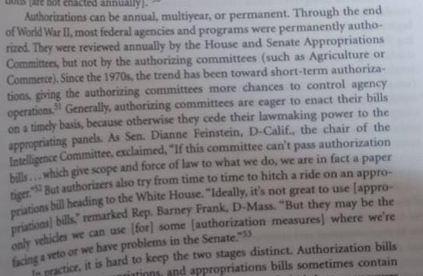

短期授權漸成為趨勢，主要原因在提供各授權委員會藉著授權法定期修訂對行政部門等有較大影響力。

講義Ch. 14 p416

撥款法有三種，年度撥款法、繼續撥款決議案、補充撥款法

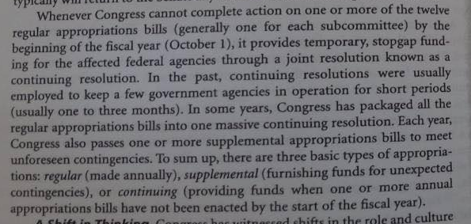

理論上授權法僅僅是政策規範，撥款法才提供所需經費，但事實上國會常在授權法中夾帶後續的撥款，在撥款法中直接作變相的政策規範。

講義Ch. 14 pp.415-6 撥款法中的限制性附加條款

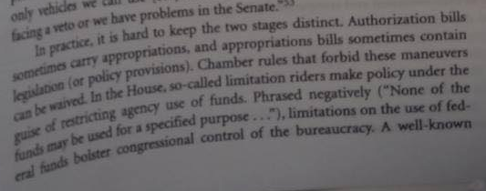

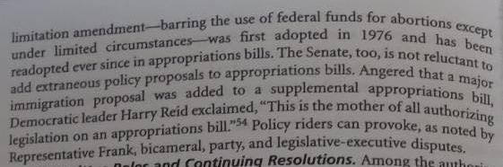

限制性附加條款 limitation riders 是指撥款法中夾帶了某些經費支用的限制，限制某項經費不得用於若干用途，這其實是一種政策規範，本應屬授權法的範圍。

講義Ch. 14 p417 授權法的三種後門支出技術Backdoor spending techniques

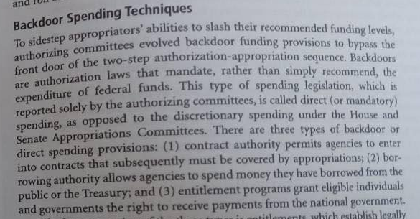

合約授權(Contract Authority)、借款授權(Borrowing Authority)、資格性計畫(Entitlement programs)三種授權法的後門中，Entitlement programs成為今日預算結構中最主要的負擔，三者的定義在講義中均有說明，資格性計畫是指符合法定資格的個人或地方政府(州政府)可以獲得聯邦經費補貼。

講義Ch. 14 pp.417-9

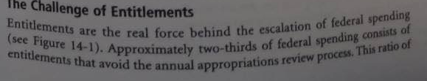

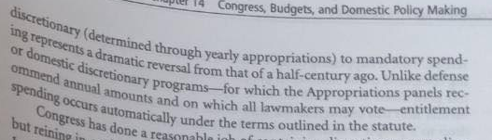

比較1965與2012四十年前後的預算結構即知，四十年前的預算結構以任意性支出占2/3，而四十年後以Entitlement programs為主的強制性支出占2/3，這些強制性支出均來自授權法，國會年度撥款程序對此無力控制，這也是美國政府赤字日益擴大的主因。

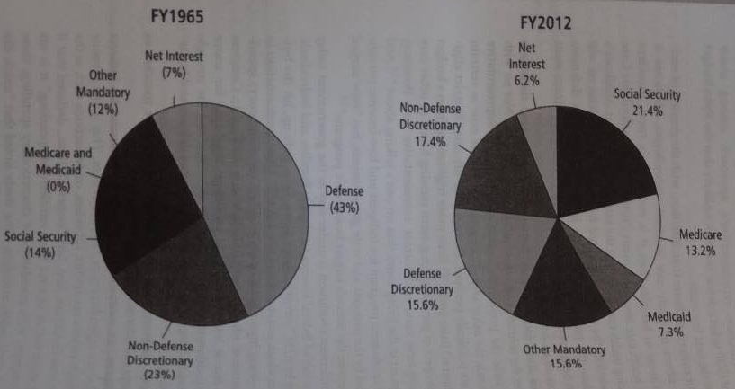

講義Ch. 14 pp.422-3

1974國會預算與保留控制法

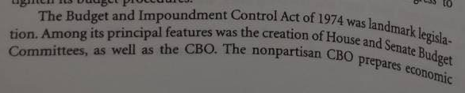

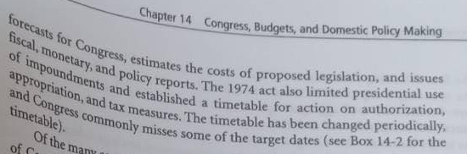

1974年法訂定了國會預算時間表

此一時間表規範了美國政府財政年度與國會預算決議案、撥款法、預算劃一法案等等的立法時程。

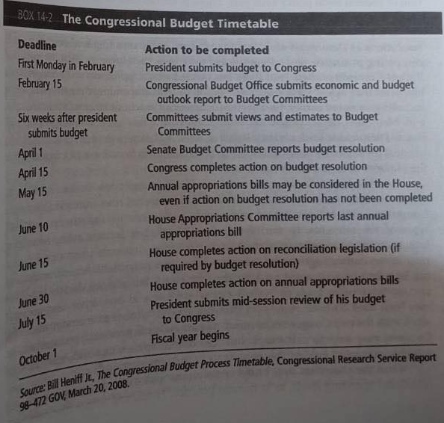

關於預算決議案、預算劃一法案下週繼續介紹。

上週有關2013年參院民主黨多數主導下的核子選擇，相關新聞影片如下，請自行點閱。

11-10a 20131121 Senate Dems go 'nuclear' on filibuster *** 2:16 bestoftv/2013/11/21/exp-erin-dnt-bash-senate-democrats-nuclear-option.cnn_640x360_dl.flv

( CNN's Dana Bash breaks down what the 'nuclear option' means for filibusters in the Senate. )

11-10b 20131121 Reid proposes controversial rule change * 1:52 politics/2013/11/21/bts-reid-senate-floor-nuclear-option.cnn_640x360_dl.flv

( Senate Majority Leader Harry Reid seeks to end Republicans' ability to filibuster executive branch nominees and judges. )

11-10c 20131121 Senators contradict former stances *** 2:59 politics/2013/11/21/exp-lead-vo-senate-nuclear-option-lawmakers-contradict-former-stances.cnn_640x360_dl.flv

( Sens Harry Reid, Mitch McConnell, even then-Sen. Barack Obama felt differently about the "nuclear option" in 2005. )

11-10d 20131122 Senate Dems nuke filibuster; What's next? ** 5:41 bestoftv/2013/11/22/ac-senate-dems-filibuster.cnn-ap_640x360_dl.flv

( Democratic leaders pulled the trigger on historic Senate rules change. Dana Bash & Jeffrey Toobin discuss look at the fallout. )

有關2017年參院共和黨多數主導下有關最高法院大法官提名案的核子選擇，相關新聞影片如下，請自行點閱。

11-10e 20170402 Senate showdown over Gorsuch * 02:18 politics/2017/04/02/neil-gorsuch-schumer-mcconnell-bts-nr.cnn_640x360_dl.flv

Sen. Chuck Schumer (D-NY) says the Supreme Court nominee will likely not get 60 votes needed to overrule a filibuster, and Sen. Mitch McConnell (R-KY) says Republicans will change the rules of the Senate to get him confirmed.

11-10f 20170403 Gorsuch nomination heads to full senate vote 00:54 politics/2017/04/03/gorsuch-nomination-heads-to-full-senate-nr.cnn_640x360_dl.flv

The Senate Judiciary Committee voted 11-9 along party lines to send Neil Gorsuch's nomination to the full Senate for a vote.

11-10g 20170403 Gorsuch Senate vote headed towards showdown 02:51 politics/2017/04/03/gorsuch-senate-confirmation-nuclear-option-serfaty.cnn_640x360_dl.flv

Senate Republicans are threatening to use the "nuclear option" to push through Neil Gorsuch's nomination despite a filibuster from Senate Democrats. CNN's Sunlen Serfaty has the latest.

11-10h 20170403 Senate headed for 'nuclear' showdown over Gorsuch 02:16 tv/2017/04/03/lead-serfaty-gop-going-nuclear-to-confirm-gorsuch-live.cnn_640x360_dl.flv

CNN's Sunlen Serfaty reports Democrats have the votes to filibuster Neil Gorsuch.

11-10i 20170405 The 'nuclear option': One thing you need to know 02:11 politics/2017/04/05/nuclear-option-senate-one-thing-to-know-orig-js.cnn_640x360_dl.flv

CNN's Chris Cillizza explains the one thing you need to know about the 'nuclear option' being invoked in the U.S. Senate.

11-10j 20170406 Senate GOP triggers nuclear option for Gorsuch 02:54 politics/2017/04/06/gorsuch-nuclear-senate-mattingly-dnt-tsr.cnn_640x360_dl.flv

The Senate triggered the so-called 'nuclear option' that allowed Republicans to break a Democratic filibuster of Supreme Court nominee Neil Gorsuch.

11-10k 20170407 Neil Gorsuch confirmed to supreme court 01:21 politics/2017/04/07/neil-gorsuch-confirmation-vote-ath.cnn_640x360_dl.flv

The Senate has reached a majority vote confirming 49-year-old federal judge Neil Gorsuch as a US Supreme Court justice.

以下是字幕檔，部分直接摘自國會紀錄

11-10a 20131121 Senate Dems go 'nuclear' on filibuster *** 2:16

exp-erin-dnt-bash-senate-democrats-nuclear-option.cnn_640x360_dl.flv

DANA BASH, CNN CHIEF CONGRESSIONAL CORRESPONDENT (voice-over): It's a historic change Democrats say will help fix a broken system.  
  
SENATOR HARRY REID, MAJORITY LEADER: It is time to change the senate before this institution becomes obsolete.  
  
BASH: And Republicans argue will make Washington gridlock worse.  
  
SENATOR JOHN MCCAIN (R), ARIZONA: Puts a chill on the entire United States Senate.  
  
BASH: Senate Democrats voted to lower the threshold to break a filibuster from 60 votes to 51 votes. It strips the minority's party ability to block a president's nominees. It is called the nuclear option for good reason. A few years ago even Democratic Leader Harry Reid said he would not do it, saying it would be --  
  
REID: A black chapter in the history of the Senate.  
  
BASH: So what about now?  
  
(on camera): So why isn't this a black chapter in the Senate.  
  
REID: Things have changed dramatically since 2005, dramatically. For the flat, the last four and a half years, they have done everything they can to deny the fact that Obama was elected and then re-elected.  
  
BASH (voice-over): Translation, GOP obstruction is unprecedented. To back that up, Democrats point to statistics from the nonpartisan Congressional Research Service. In the history of the country there have been 168 filibusters of presidential nominees. About half, 82, happened during the Obama administration.  
  
SENATOR LAMAR ALEXANDER (R), TENNESSEE: In summary, this is a power grab.  
BASH: Angry Republicans don't necessarily dispute Democrats' statistics about nominees they have blocked instead they point to how many judges they have confirmed, 215 and rejected five. The president who opposed to their tag particular as a senator changed his tune.  
  
BARACK OBAMA, PRESIDENT OF THE UNITED STATES OF AMERICA: The vote today I think is an indication that a majority of senators believe as I believe that enough is enough.  
  
BASH: When it comes to the fight that Democrats call the last straw over vacancies in the D.C. Circuit Court of Appeals, the Republican leader argues, Democrats are manufacturing a crisis to distract from the Obamacare debacle.  
  
SENATOR MITCH MCCONNELL (R), MINORITY LEADER: A fake fight over judges that are not even need.  
  
(END VIDEOTAPE)  
  
BASH: Democrats say that they get that this landmark change that they pushed through in the rules of the Senate benefits them now that they're in the majority, but could really hurt them the day that they become the minority party in the Senate. But they say it is a risk that they really have to take in order to change what they call continued obstructionism.

<https://transcripts.cnn.com/show/ebo/date/2013-11-21/segment/01>

**********************

11-10b 20131121 Reid proposes controversial rule change * 1:52

bts-reid-senate-floor-nuclear-option.cnn_640x360_dl.flv

SEN. HARRY REID, (D) MAJORITY LEADER: Congress should be passing legislation that strengthens our economy, protects American families. Instead, we're burning wasted hours, and wasted days between filibusters.

Congressional Record *November 21, 2013* S8414

The change we propose today would ensure executive and judicial nominations an up-or-down vote on confirmation— yes, no.

The rule change will make cloture for all nominations other than for the Supreme Court a majority threshold vote—yes or no.

The Senate is a living thing, and to survive it must change, as it has over the history of this great country. To the average American, adapting the rules to make the Senate work again is just common sense.

This is not about Democrats versus Republicans. This is about making Washington work—regardless of who is in the White House or who controls the Senate. To remain relevant and effective as an institution, the Senate must evolve to meet the challenges of this modern era.

Congressional Record *November 21, 2013* S8415

The PRESIDENT pro tempore. The Republican leader is recognized.

Mr. MCCONNELL. Once again, Senate Democrats are threatening to break the rules of the Senate—break the rules of the Senate— in order to change the rules of the Senate.

And over what? Over what?

Over a court that does not even have enough work to do?

Millions of Americans are hurting because of a law Washington Democrats forced upon them, and what do they do about it? They cook up some fake fight over judges—

Congressional Record *November 21, 2013* S8415

So this business of filibustering circuit court judges was entirely an invention of the guys over here on the other side, the ones you are looking at right over here. They made it up. They started it. This is where we ended up.

Congressional Record *November 21, 2013* S8416

********************

11-10c 20131121 Senators contradict former stances *** 2:59

exp-lead-vo-senate-nuclear-option-lawmakers-contradict-former-stances.cnn_640x360_dl.flv

JAKE TAPPER, CNN ANCHOR:

We're now living in the aftermath of a nuclear strike, metaphorically speaking, of course. In the politics lead, Senate Democrats really did it. They changed the rules so now it only takes a simple majority vote of 51 to break a filibuster on executive and judicial rules, instead of 60 votes under the old rules. It's been referred to as the nuclear option.  
  
And it went something like this on the Senate floor, Democrats pulling a Strangelove out of frustration over Republicans blocking President Obama's nominees to an unprecedented degree. But today's action did not require both parties turning the launch keys. President Obama today applauded the move, claiming that the obstructionism from the other side has gotten so bad there was little choice.  
  
(BEGIN VIDEO CLIP)  
  
BARACK OBAMA, PRESIDENT OF THE UNITED STATES: Today's pattern of obstruction, it just isn't normal. I support the step a majority of senators today took to change the way that Washington is doing business.  
  
(END VIDEO CLIP)  
  
TAPPER: Hmm. That's interesting. You know who might not agree with President Obama? Senator Obama in 2005, when the Republicans were trying to do the same thing as the majority power party, to push George W. Bush's nominees through. Back, of course, then, it was pronounced "nucular" option. Here's what the president said about that in 2005.  
  
(BEGIN VIDEO CLIP)  
  
OBAMA: But if the right of free and open debate is taken away from the minority party and the millions of Americans who ask us to be their voice, I fear that the already partisan atmosphere in Washington will be poisoned to the point where no one will be able to agree on anything.  
  
(END VIDEO CLIP)  
  
TAPPER: Republicans obviously today are furious about this rule change that takes away one of the most powerful weapons in the Senate for the minority party. Senate Minority Leader Mitch McConnell today reminded his Democratic colleagues that they might not like this rule change so much if they find themselves in the minority in the future. (BEGIN VIDEO CLIP)  
  
SEN. MITCH MCCONNELL (R-KY), MINORITY LEADER: Rather than learn from past precedents on judicial nominations that they themselves set, Democrats now want to set another one. I have no doubt that, if they do, they will come to regret that one as well.  
  
(END VIDEO CLIP)  
  
TAPPER: You who might disagree with, Senator McConnell? Senator McConnell, back in 2005. Back then, he thought it was a swell idea since his party was in the majority and was sick of Democratic obstructionism.  
  
(BEGIN VIDEO CLIP)  
  
MCCONNELL: The current Senate majority intends to do what the majority in the Senate has often done, to reform Senate procedure by a simple majority vote.  
  
Despite the incredulous protestations of our Democratic colleagues, the Senate has repeatedly adjusted its rules as circumstances dictate.  
(END VIDEO CLIP)  
TAPPER: Do you like this, where I show a clip from today, and then a clip from 2005 where the person says the exact opposite? I could do this for the whole show. There's no end to the clips of senators contradicting their former stances on the nuclear option ever since control of the Senate shifted in 2007.

<https://transcripts.cnn.com/show/cg/date/2013-11-21/segment/01>

*********************

11-10d 20131122 Senate Dems nuke filibuster; What's next? ** 5:41

ac-senate-dems-filibuster.cnn-ap_640x360_dl.flv

ANDERSON COOPER, CNN ANCHOR:

We begin with the biggest change in the way government does business -- your business, in decades. Because it involves Senate rules and Latin words and partisan bickering, the temptation is to tune out. The fact is, though, what Democrats in the United States Senate today matters if you care who runs government agencies who touch the life or courts or cabinet departments.

All involve people nominated by the president and confirmed by the Senate. Confirmation takes a simple majority, 51 votes, however, any senator can demand a higher threshold, a super majority of 60 votes.

Today citing all the times the Republicans have used that 60-vote hurdle to block presidential nominees, Senate Democrats today voted to take it off the table for all but Supreme Court nominees.

That change is called the nuclear option. And it's what the name implies, a really big deal, blows up the rules.

The question is, why did the Democrats do it? President Obama made a surprise visit to the press briefing room and singled out the GOP.

(BEGIN VIDEO CLIP)

BARACK OBAMA, PRESIDENT OF THE UNITED STATES: I realize that neither party has been blameless for these tactics. They have developed over years and it seems as if they've continually escalated but today's pattern of obstruction, it just isn't normal. It's not what our founders envisioned.

A deliberate and determined effort to obstruct everything no matter what the merits just to refight the results of an election is not normal. And for the sake of future generations, we can't let it become normal.

(END VIDEO CLIP)

COOPER: Republicans meantime are threatening retaliation. They are also claiming hypocrisy, pointing out that leading Democrats including a then Senator Obama opposed a nuclear option back when Republicans controlled the Senate.

(BEGIN VIDEO CLIP)

SEN. BARACK OBAMA (D), ILLINOIS: If the majority chooses to end the filibuster, if they choose to change the rules and put an end to democratic debate, then the fighting and the bitterness and the gridlock will only get worse.

SEN. JOSEPH BIDEN (D), DELAWARE: This nuclear option is ultimately an example of the arrogance of power. It is a fundamental power grab by the majority party.

SEN. HARRY REID (D), NEVADA: Senators have used the filibuster to stand up to popular presidents. To block legislation. Yes, even as I've stated, to stall executive nominees. The roots of the filibuster are found in the Constitution and in our own rules. It will change the Senate forever and that's not good.

(END VIDEO CLIP)

COOPER: All right. Well, they were all pretty clear about it back then. Asked today by Dana Bash why the flip-flop Senator Reid said, quote, "I have the right to change how I feel about things."

Dana joins us now along with senior legal analyst Jeffrey Toobin.

So no doubt plenty of hypocrisy to go around but in terms of blocking nominees, is it really as bad as the Democrats are claiming, Dana?

DANA BASH, CNN CHIEF CONGRESSIONAL CORRESPONDENT: Well, it certainly is different. They are right about that and you just have to look at the facts that the nonpartisan Congressional Research Service put out, and that is that of all the filibusters in the history of the Senate, when you're talking about nominees, half of them have happened during the Obama administration.

Now if you dig deeper into that, people can differ about what you actually call a filibuster, but regardless, it certainly has been more than before and so that really is another reason, Anderson, that Harry Reid gave the answer to me that he did, which is he's changed because of the fact that the atmosphere has changed. COOPER: Jeff, we've been hearing threats to blow up the filibuster for a long time. Why now?

JEFFREY TOOBIN, CNN SENIOR LEGAL ANALYST: Because the situation got so extreme. You know --

COOPER: So you buy into it. You say it really is extreme?

TOOBIN: You know, absolutely. You know, Barack Obama has nominated five people to the D.C. Circuit, which is the second most important court in the country. It's really the farm team for the Supreme Court. It's where John Roberts were, Clarence Thomas, Antonin Scalia, Ruth Bader-Ginsburg, all were there before they went on the Supreme Court.

Of those five nominations, four were filibustered. What this -- and, you know, that's just unprecedented. What today's vote will mean is that three of those four will now get on the D.C. Circuit, and that could have major implications for whether the laws that Obama managed to pass in his first term are upheld now that the -- now that the challenges are starting to work their way through the court.

COOPER: So, Dana, what about on the Republican side? I mean, they're saying they're outraged by what -- by what happened. Is this going to poison the well for future bipartisan agreements?

BASH: It could. There is no question about it. Even Republicans who tend to work across the aisle like John McCain was telling me and other reporters today that it might be harder for him to do things like get treaties passed which require big majority -- super majorities of 67 votes because of the fact that Republicans may support the concept of the issue at hand, but they might not want to give Democrats a win after they have had their feathers ruffled.

But the other thing to keep in mind is just sort of big picture and practical level, what you're going to see now is pretty much every one of the president's nominees except for the Supreme Court, which is a whole different issue, is going to get through the Senate unless there is some really controversial issue about qualifications and that is a big, big change.

COOPER: And Jeff, do you think this is maybe as important to Obama's legacy as Obamacare?

TOOBIN: Absolutely. Especially when you consider the current political context. The House is in Republican hands. No legislation, not even immigration, it appears, is going to get through. So there are not going to be any laws passed. So all Obama can do now for the rest of his term is to get his people on the courts, in administrative agencies, and this is how he can do it because now he only needs 50 votes.

It certainly raises the stakes for the 2014 midterm elections because a lot of those Democrats are up for reelection. If the Republicans retake the Senate in 2014, nothing is going to happen the last two years of Obama's presidency.

<http://transcripts.cnn.com/TRANSCRIPTS/1311/21/acd.01.html>

**************************

11-10e 20170402 Senate showdown over Gorsuch * 02:18

neil-gorsuch-schumer-mcconnell-bts-nr.cnn_640x360_dl.flv

FREDRICKA WHITFIELD, CNN ANCHOR:

[14:43:04] WHITFIELD: All right. The battle to confirm Supreme Court pick Neil Gorsuch is heating up. Tomorrow the Senate Judiciary Committee is expected to vote on whether to send his nomination to the full Senate and that final confirmation vote is expected to happen on Friday. But there are big challenges ahead. Right now it's unclear whether Republicans have the votes to break a Democratic filibuster. In order to do that, Republicans need 60 votes. That means they need eight Democrats to get on board. And so far only three Democrats have said they will vote yes. And here they are.  
  
Republicans also weighing in on the so-called nuclear option which would change Senate rules to get around a filibuster. This morning lawmakers on both sides of the aisle are weighing in.  
  
(BEGIN VIDEO CLIP)  
SEN. MITCH MCCONNELL (R), MAJORITY LEADER: Judge Gorsuch is going to be confirmed. The way in which that occurs is in the hands of the Democratic minority. And I think during the course of the week we'll find out exactly how this will end but it will end with his confirmation.  
  
SEN. CHARLES SCHUMER (D), MINORITY LEADER: Why doesn't President Trump, Democrats and Republicans in the Senate, sit down and try to come up with a mainstream nominee?

***************

ARIANE DE VOGUE, CNN SUPREME COURT CORRESPONDENT: Well, like you said tomorrow is a big day. The Senate Judiciary Committee is going to vote. We expect Gorsuch to advance. And that we also expect to get more of a sense where some of these key Democrats are. Right now it's about the math. As you said, as things stand it takes 60 votes to confirm him and as of Friday 36 Democrats led by Chuck Schumer suggested they might filibuster, but three Democrats and one just today said that look, they're going to support him.  
  
[14:45:03] Those were Manchin from West Virginia, Heitkamp from North Dakota, and Donnelly from Indiana. They all come from states where Trump won. They said look, they're furious about Merrick Garland never getting a vote but elections matter. They say that Gorsuch is qualified.  
  
On the other side the Republicans come back and they say look, if you're going to do something historic like this, and change -- and filibuster, then we will change the way the rules are and we'll make it easier for Supreme Court nominees to get through. So both sides are saying something historic is about to happen and McConnell, he said look, there is going to be a vote no matter what happens on Friday.

<https://transcripts.cnn.com/show/cnr/date/2017-04-02/segment/01>

*********************

11-10f 20170403 Gorsuch nomination heads to full senate vote 00:54

gorsuch-nomination-heads-to-full-senate-nr.cnn_640x360_dl.flv

SEN. CHUCK GRASSLEY, (R-IA), CHAIRMAN, SENATE JUDICIARY COMITTEE:  
GRASSLEY: A very highly qualified justice, future justice on the Supreme Court. We have heard that there's going to be a filibuster. And if the Democrats will filibuster this person of the high quality he is that there isn't any justice that a Republican would put forth that they would get his -- that they would support. So consequently, this seems, to me to be something that puts us in a situation of reconsidering exactly for the other side to reconsider what they do in regard to justices if they want the system of confirmation to work.

<https://transcripts.cnn.com/show/cnr/date/2017-04-03/segment/06>

**********************************

11-10g 20170403 Gorsuch Senate vote headed towards showdown 02:51

gorsuch-senate-confirmation-nuclear-option-serfaty.cnn_640x360_dl.flv

SEN. DIANNE FEINSTEIN (D), CALIFORNIA: Judge Gorsuch's answers were so diluted with ambiguity, one could not see where he stood.

SUNLEN SERFATY, CNN NATIONAL CORRESPONDENT:  
SERFATY (voice-over): The partisan battle lines are now fully drawn.  
  
SEN. ORRIN HATCH (R), UTAH: Our colleagues on the other side who are willing to vote against the nominee for the United States Supreme Court, for the first time in history conduct a filibuster, I think that's unworthy of the Senate.  
  
SERFATY: The Senate is now headed toward a high-stakes showdown over President Trump's Supreme Court nominee, Neil Gorsuch.  
  
SEAN SPICER, WHITE HOUSE PRESS SECRETARY: The Democrats are setting a very dangerous precedent.  
  
SERFATY: Today, Democrats locked in enough support to successfully filibuster Gorsuch when he faces the full Senate later this week.  
  
SEN. CHRIS COONS (D), DELAWARE: I'm not ready to end debate on this issue, so I will be voting against cloture, unless we are able as a body to finally sit down and find a way to avoid the nuclear option. SERFATY: According to CNN vote count, Senator Coons' support today  
  
marks the 41st Democrat to sign onto a filibuster, making it impossible by the math for Republicans to get the 60 votes needed to break the filibuster.  
  
SEN. THOM TILLIS (R), NORTH CAROLINA: It's an amazing theater that we have created here to create this pretext for a partisan filibuster. This is not going to be successful.  
  
SERFATY: Meaning Republicans will have to make good on their promise to invoke the so-called nuclear option to get Gorsuch through. Senate Majority Leader Mitch McConnell not mincing words about what he intends to do when Gorsuch faces the full Senate.  
  
SEN. MITCH MCCONNELL (R-KY), MAJORITY LEADER: What I can tell you is that Neil Gorsuch will be confirmed this week.  
  
[18:05:01]  
  
SERFATY: The nuclear option will change Senate rules so that Gorsuch and future Supreme Court nominees will only need a simple majority, 51 votes, to get through, rather than the 60 votes that had been established under longstanding Senate rule.  
  
SEN. LINDSEY GRAHAM (R), SOUTH CAROLINA: Yes, this is going to be very bad. I'm going to tell you what is going to happen. The judges will become more ideological because you don't have to reach across the aisle to get one vote any longer. This is going to haunt the Senate. It's going to change the judiciary. And it's so unnecessary.

SEN. CHUCK GRASSLEY, (R-IA), CHAIRMAN, SENATE JUDICIARY COMITTEE:

For now raise to vote on a nomination of judge Neil Gorsuch.

SERFATY: Today, Gorsuch's nomination advanced on a party-line vote out of the Senate Judiciary Committee, the last step before reaching the Senate floor, giving Democrats the opportunity to sound off on the process.  
  
FEINSTEIN: This nomination is not the usual nomination. It comes in a different way. And it has proceeded in a way of excessive spending of dark money that, in the time I have been on this committee, I have never seen before.  
  
SERFATY: And the nominee.  
  
SEN. AL FRANKEN (D), MINNESOTA: And I'm disappointed that Judge Gorsuch wasn't forthcoming with his answers.  
  
SERFATY: With Republicans crying foul.  
  
SEN. JOHN CORNYN (R), TEXAS: If they're going to oppose Neil Gorsuch to the Supreme Court of the United States, they will never vote and never support a nominee of this president.

<https://transcripts.cnn.com/show/sitroom/date/2017-04-03/segment/02>

******************

11-10h 20170403 Senate headed for 'nuclear' showdown over Gorsuch 02:16

lead-serfaty-gop-going-nuclear-to-confirm-gorsuch-live.cnn_640x360_dl.flv

JAKE TAPPER, CNN ANCHOR:

High drama on Capitol Hill today in the fight over Supreme Court nominee Neil Gorsuch. As of this afternoon, 41 Senate Democrats will vote no on procedural motion to allow a vote on the Gorsuch confirmation. That means essentially Democrats are threatening to filibuster the nomination.  
  
And now Republicans are poised to change the rules and blow out the way the Senate operates. CNN's Sunlen Serfaty is live for us on Capitol Hill.  
  
And, Sunlen, both moves are rather historic, both the threatened filibuster of Gorsuch and the detonation of the Senate rules.  
  
SUNLEN SERFATY, CNN NATIONAL CORRESPONDENT: That's right, Jake.  
  
Democrats and Republicans here have both essentially forced the other's hand here, underscoring just how partisan it is up here on Capitol Hill. Now, back in 2013, you will remember Democrats did lay some groundwork on this when they were in the majority.  
  
They invoked the nuclear option. They changed the Senate rules to require a simple majority for non-Supreme Court justice nominees.  
  
But certainly there is a sense that this is a Supreme Court nominee, a potential lifetime appointment, so we are entering some uncharted territory here.  
  
We saw Democrats throughout this debate, yes, really going against Gorsuch, saying they have questions about his record, and a lot of them today saying that he had not been forthcoming enough.  
  
But we saw them at the same time really railing against the fact that Merrick Garland, President Trump's Supreme Court nominee, was never held up for a vote. Here's some rhetoric coming from both sides today really underscoring how much all of this really is steeped in politics.  
(BEGIN VIDEO CLIP)  
SEN. LINDSEY GRAHAM (R), SOUTH CAROLINA: I am going to vote to change the rules because I'm not going to be part of a Senate where Democrats get their judges and a Republican can never get theirs.  
  
SEN. CHRIS COONS (D), DELAWARE: I question what a seven-month refusal to hold a hearing or a vote is, if not the longest partisan filibuster on this committee ever.  
(END VIDEOTAPE)  
  
SERFATY: What happens on all of this next?  
  
We expect Senate Majority Leader Mitch McConnell to set up a key procedural vote for Thursday morning. We expect that the filibuster will not be broken. That's when and if likely he invoke the nuclear option, Jake. This sets a potential final confirmation vote for Neil Gorsuch on Friday, importantly, with only 51 votes, if they invoke the nuclear opposition necessary.  
  
TAPPER: All right, Sunlen Serfaty up on Capitol Hill for us, thank you so much.

<https://transcripts.cnn.com/show/cg/date/2017-04-03/segment/01>

**********************

11-10i 20170405 The 'nuclear option': One thing you need to know 02:11

nuclear-option-senate-one-thing-to-know-orig-js.cnn_640x360_dl.flv

CHRIS CILLIZZA, CNN POLITICS EDITOR-AT-LARGE:

The one thing to know about the nuclear option is you may not understand it, but it does really matter.

The nuclear option is sort of a commonplace term for a way in which the filibuster rules of the Senate are end run, usually to stop debate on any matter in front of the Senate, you need to get 60 votes. But if you use the nuclear option, you take that 60 vote margin and take it down to a majority 51 vote threshold.

In 2013 Harry Reid, after months and months of threatening to deploy the nuclear option.

Actually did it.

HARRY REID, Senate Majority Leader(2013), It's time to get the Senate working again. Not for the good of the current Democratic majority or some future Republican majority, but for the good of the United States of America.

CILLIZZA:

The filibuster, whether real or threatened, had always been a way that the Senate distinguished itself from the House. The house very much runs on a majority rule rule. If you have the votes, you have the votes in the Senate in order to close off that debate, which means to force an actual majority. Vote you needed always to have 60. It required, typically some bipartisan consensus building, because neither party often had 60 plus seats in their control. When you remove that, you start to slide even further down the slippery slope that Harry Reid started us all on in 2013. If we've already wiped out the use of the traditional filibuster that 60 vote margin on several big things, including Supreme Court nominees, what's to stop either this majority?

Or the next majority Democrat or Republican from instituting it on legislative matters. And at that point, the Senate fully becomes the House.

MITCH MCCONNELL, Senate Majority Leader, UNITED STATES SENATOR FROM KENTUCKY: Judge. Gorsuch is going to be confirmed the way in which that occurs is in the hands of the democratic minority.

CILLIZZA:

Getting rid of the 60 vote margin or the filibuster threat. While bad for democracy, is frankly a good thing for political party bases.

There will be no penalty at the ballot box for these sorts of things, which makes me think we may see more erosion rather than less of the filibuster in years to come.

******************************

11-10j 20170406 Senate GOP triggers nuclear option for Gorsuch 02:54

gorsuch-nuclear-senate-mattingly-dnt-tsr.cnn_640x360_dl.flv

PHIL MATTINGLY, CNN CONGRESSIONAL CORRESPONDENT:  
MATTINGLY: Tonight, senate republicans have triggered the so-called "nuclear option".  
  
MITCH MCCONNELL, UNITED STATES SENATOR FROM KENTUCKY: Therefore, I raise the point of order that the vote on cloture under the precedent set on November 21st, 2013 is a majority vote on all nominations.  
  
MATTINGLY: Senate Majority Leader, Mitch McConnell, making a historic change to the senate rules to clear the path forward for President Trump's Supreme Court nominee. CHARLES SCHUMER, UNITED STATES SENATOR FROM NEW YORK: Today's vote is  
  
a cautionary tale about how unbridled partisan escalation can ultimately overwhelm our basic inclination to work together.  
  
MATTINGLY: Republicans repeatedly touting nominee Neil Gorsuch's qualifications and blaming anger at Trump for the democratic block aid.  
[17:45:05] MCCONNELL: The opposition to this particular nominee is more about the man that nominated him and the party he represents than the nominee himself.  
  
CHARLES GRASSLEY, UNITED STATES SENATOR FROM IOWA: You know that he'll be confirmed and you know in your hearts of heart that he deserves to be confirmed, and that's why this is especially sad state of affairs.  
  
MATTINGLY: The change, that so-called "nuclear option", dropped the threshold to advance Gorsuch's nomination from 60 to just 51 votes, giving republicans who hold 52 seats in the chamber the ability to work with no democratic help.  
  
SCHUMER: In a post-nuclear world, if the senate and the presidency are in these hands of the same party, there's no incentive to even speak to the senate minority. That's a recipe for more conflict and bad blood between the parties, not less.  
  
MATTINGLY: The move marks a culmination or perhaps continuation of events set into motion over years of mistrust and partisanship. And it follows the 2013 democratic move that made the same change for lower court appointees.  
  
HARRY REID, FORMER UNITED STATES SENATOR: It's time to change the senate before this institution becomes obsolete.  
  
MATTINGLY: It was done then to overcome GOP blockades of many of President Obama's nominees and drew this starkly prescient warning from then-Minority Leader, McConnell.  
  
MCCONNELL: Outside of the aisle, you'll regret this. And you may regret it a lot sooner than you think.  
  
MATTINGLY: McConnell now escalating deeply embedded partisan tensions himself with a move even some republican colleagues are criticizing.  
JOHN MCCAIN, UNITED STATES SENATOR FROM ARIZONA: I find myself torn between protecting the traditions and practices of the senate and the importance of having a full complement of justices on the U.S. Supreme Court.  
  
MATTINGLY: Even as they all voted in favor.  
  
UNIDENTIFIED FEMALE: Mr. McCain? Aye.  
  
MATTINGLY: Making clear that by week's end Mr. Trump's first pick for the highest court in the land will be confirmed. (END VIDEOTAPE)

<https://transcripts.cnn.com/show/sitroom/date/2017-04-06/segment/01>

*************************

11-10k 20170407 Neil Gorsuch confirmed to supreme court 01:21

neil-gorsuch-confirmation-vote-ath.cnn_640x360_dl.flv

KATE BOLDUAN, CNN ANCHOR:

OK.

Voting is still under way, but importantly, Republicans have now passed the threshold. 52 Senators have voted in support of Neil Gorsuch. Voting still under way, but he has now reached the threshold of a simple majority. 52 Senators voting to confirm Neil Gorsuch. Voting to confirm Neil Gorsuch, so we have this very important moment.  
  
And miraculously, and magically, we have someone else who has just joined us at the table. Jeffrey Toobin, CNN legal analyst, joining us here.  
  
Jeffrey, I know you're listening to the other conversation and we were waiting for this moment. This was expected. What does this mean for the court in the most immediate sense? Does he hit the ground running?  
  
JEFFREY TOOBIN, CNN SENIOR LEGAL ANAYST: Oh, absolutely. He has been a federal appeals court judge for 10 years, so he knows precisely what he is doing. He is a former law clerk. In fact, he is the first Supreme Court justice in history to serve with, alongside the justice for whom he was a law clerk.  
  
BOLDUAN: That's right.

TOOBIN: He was a law clerk for Anthony Kennedy. He's 49 years old.  
  
He's very likely to be on the Supreme Court for several decades. And this re-establishes a conservative majority on the court, replacing Antonin Scalia with another conservative.  
  
And you know, there have only been 112 Supreme Court justices in American history, so anytime one is confirmed is a major event.

<https://transcripts.cnn.com/show/ath/date/2017-04-07/segment/02>